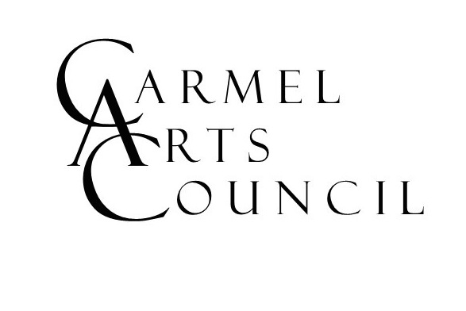
Carmel Arts Council
APPLICATION FOR GUILD MEMBERSHIP
www.carmelartscouncil.org

Name ______________________________ E-Mail Address________________________

Street Address______________________________________________________________

City________________________ State__________ Zip ____________

Cell Phone: ____________________ Home Phone: ____________________

Please identify any experiences, memberships or other facts that could assist CAC in considering your application and explain your volunteer experience on the back side of this application. Thank you.

Art/Music Outreach ____ Hospitality ____ Mailings ____ Public Relations ___ Marketing ____

Event Planning ____ Speaking ____ Finance ____ Volunteer Activities ____

Fund Raising ____ Silent Auctions ____ Web Site Maintenance ____ Computer Skills _____

Attachment Required. Please attach a statement to this application explaining why being a CAC guild member is important to you and what your membership would bring to the CAC. Also please tell us about your passion for, and commitment to, the arts.

Criminal background check. As a nonprofit organization, the CAC and its members have direct and significant contact with the public, including children. You will need to provide a criminal background check to us to complete your application. Please use the following link to complete the check: www.in.gov/ai/appfiles/isp-lch/index.html

Please mail the completed application and attachment to Carmel Arts Council, P.O. Box 344, Carmel, IN 46082
You will be contacted by a board member to meet and discuss membership.

Upon acceptance your yearly dues will be $25.

The CAC sincerely thanks you for your interest!

Summer 2018 Revision

